**COMP47500 Assignment: Queues & Deques**

**Part A: Theory**

3) Show how the state of both an array-based and a link-based Queue changes after each of the following operations:

*enqueue(‘Ireland’), dequeue(),enqueue(‘England’), dequeue(), enqueue(‘Wales’), dequeue(), enqueue(‘Scotland’), dequeue(), enqueue(‘France’), enqueue(‘Germany’)*

After the last operation, list the countries that were dequeued from the Queue and the countries held in the Queue.

**Array-based**

F-Front R-Rear

|  |  |  |  |  |  |  |  |  |
| --- | --- | --- | --- | --- | --- | --- | --- | --- |
| Operation | F | R | 0 | 1 | 2 | 3 | 4 | 5 |
| Initial State | 0 | 0 |  |  |  |  |  |  |
| enqueue(‘Ireland’) | 0 | 1 | Ireland |  |  |  |  |  |
| dequeue() | 1 | 1 |  |  |  |  |  |  |
| enqueue(‘England’) | 1 | 2 |  | England |  |  |  |  |
| dequeue() | 2 | 2 |  |  |  |  |  |  |
| enqueue(‘Wales’) | 2 | 3 |  |  | Wales |  |  |  |
| dequeue() | 3 | 3 |  |  |  |  |  |  |
| enqueue(‘Scotland’) | 3 | 4 |  |  |  | Scotland |  |  |
| dequeue() | 4 | 4 |  |  |  |  |  |  |
| enqueue(‘France’) | 4 | 5 |  |  |  |  | France |  |
| enqueue(‘Germany’) | 4 | 6 |  |  |  |  | France | Germany |

**Link-based**

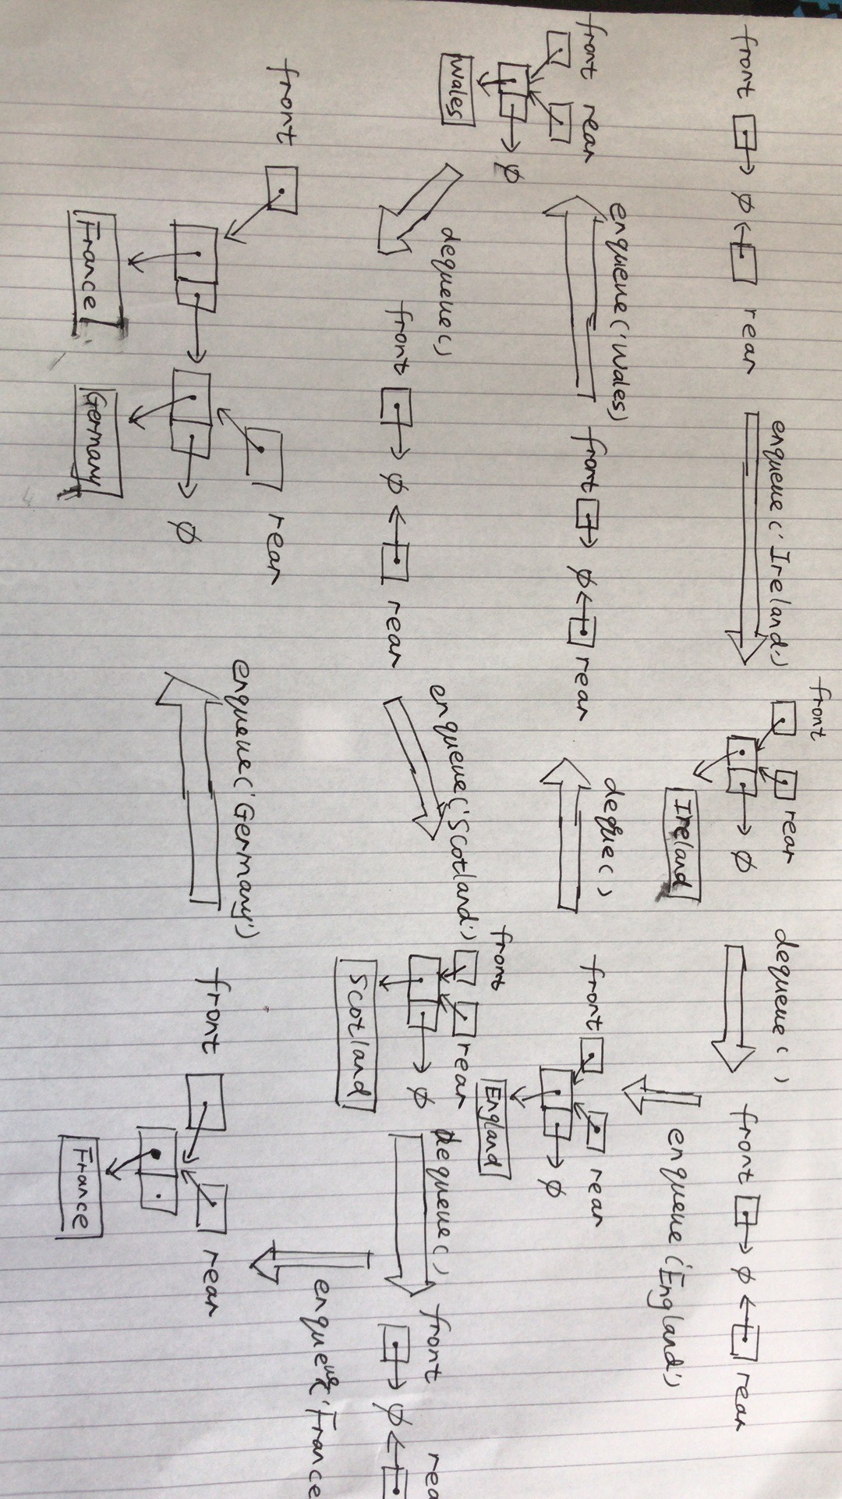

Countries Held: France, Germany

Countries Dequeued: Ireland, England, Wales, Scotland

4) Write out the pseudo code for the insertLast(o) operation of the Deque ADT. The insertFirst(o) pseudo code is given below as an example of a similar operation

**Algorithm insertLast(o)**

Input: an object o

Output:N/A

node <- new Node(o)

node.prev <- rear

**if** rear = null **then**

front <- node

**else**

rear.next <- node

rear <- node

size <- size + 1

*NOTE: once you have written a first version of your pseudo code, test it using two dry runs: (1) inserting into an empty Deque, and (2) inserting into a non-empty Deque.*

1. inserting into an empty Deque

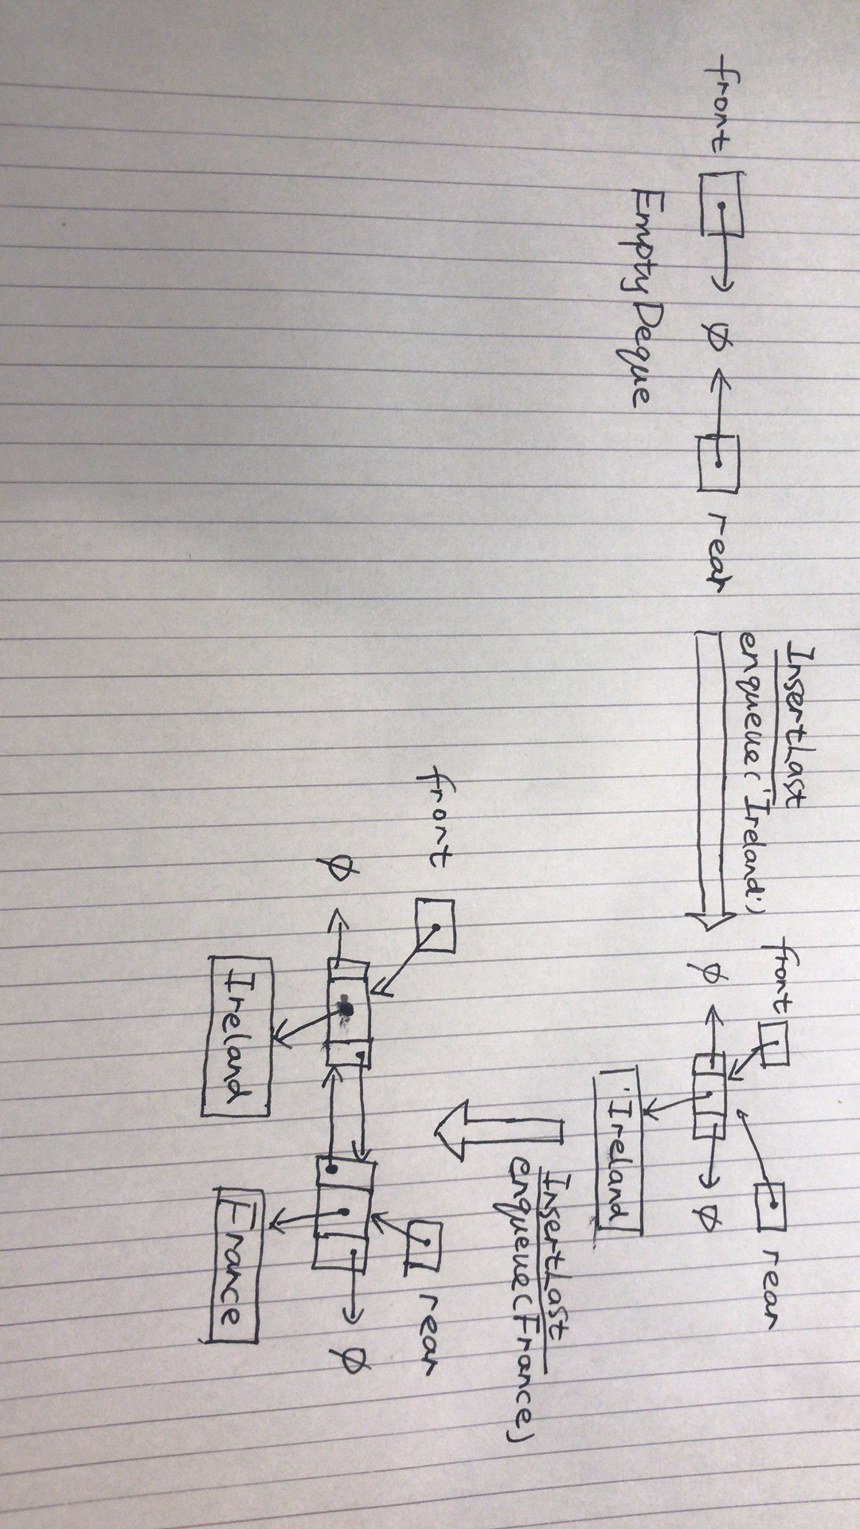

1. inserting into a non-empty Deque

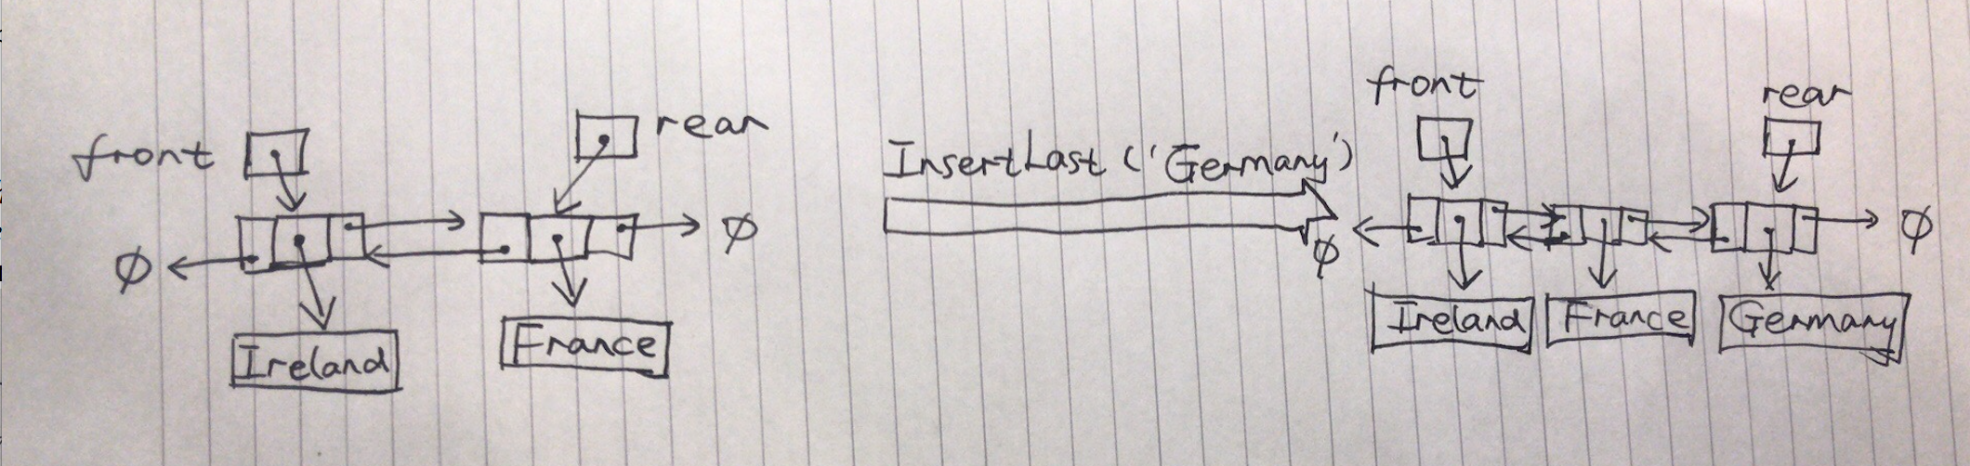

5) Write out the pseudo code for the removeLast() and removeFirst() operations of the Deque ADT. As with question 4, for each removal operation consider 2 cases: (1) a Deque containing 1 item and (2) a Deque containing more than 1 item.

**Algorithm removeLast()**

Input: none

Output: the node has been removed

node <- rear

rear <- rear.prev

**if** rear = null **then**

front <- null

**else**

rear.next <- node

size <- size – 1

return node.element

case1: 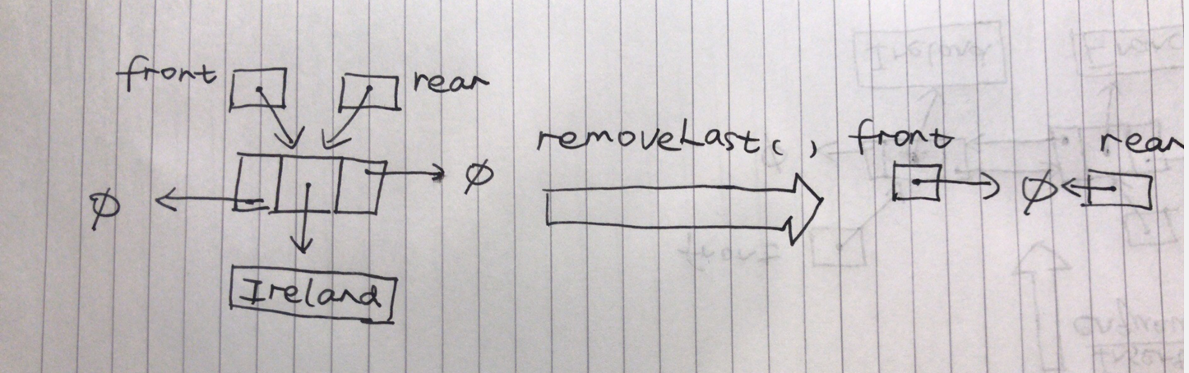

case2:

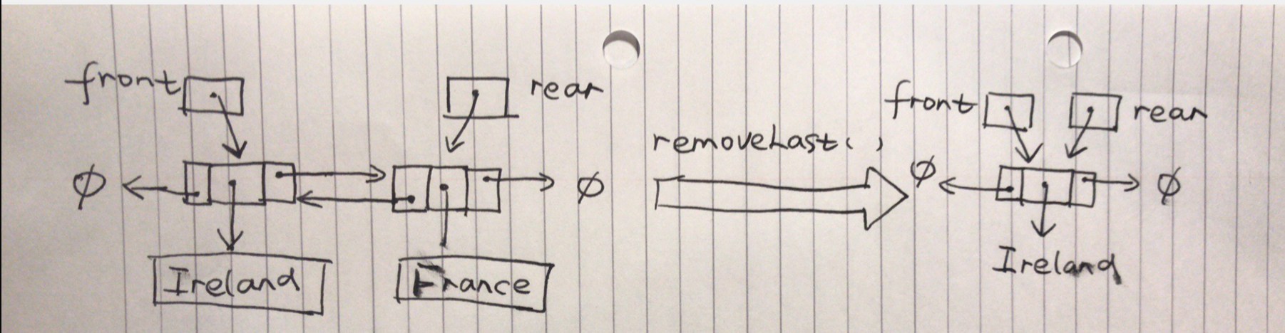

**Algorithm removeFirst()**

Input: none

Output: the node has been removed

node <- front

front <- front.next

**if** front = null **then**

rear <- null

**else**

rear.next <- null

size <- size – 1

return node.element

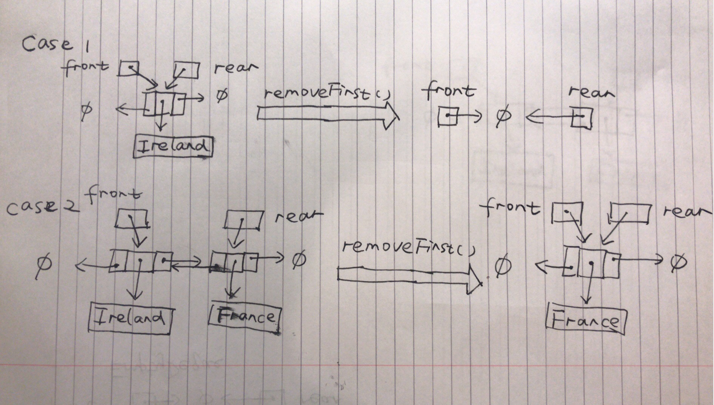

6) Write out the pseudo code for the isEmpty(), size(), front() and rear() operations of the Deque ADT.

**Algorithm** isEmpty()

Input: none

Output: true if the deque is empty, false otherwise

**return** size==0

**Algorithm** size()

Input: none

Output: count of objects on the deque

**return** size

**Algorithm** front()

Input: none

Output: front object

**return** front.element

**Algorithm** rear()

Input: none

Output: rear object

**return** rear.element

7) Show how the state of a link-based Deque changes after each of the following operations:

*insertFirst(‘Ireland’), removeLast(),insertLast(‘England’), removeFirst(), insertLast(‘Wales’), insertFirst(‘Scotland’), insertLast(‘France’), removeFirst(), removeLast(), insertLast(‘Germany’)*

After the last operation, list the countries that were removed from the Deque and the countries held in the Deque.

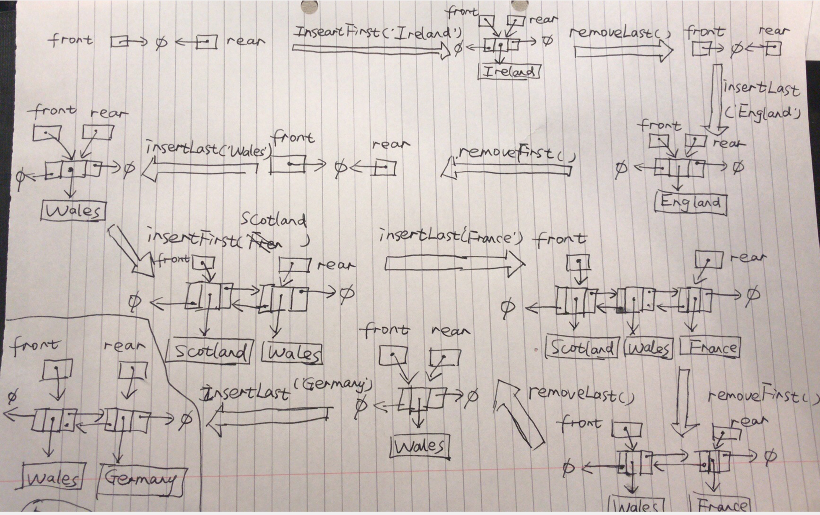

Countries Held: Wales, Germany

Countries Dequeued: Ireland, England, Scotland, France

**Part B: Queue & Deque Implementations**

1. ArrayQueue

**public class** ArrayQueue<E> **implements** Queue<E> {  
 **private** E[] **Q**;  
 **private int N** = 1000;  
 **private int front** = 0;  
 **private int rear** = 0;  
  
 *//default constructor* **public** ArrayQueue() {  
 **Q** = (E[]) (**new** Object[**N**]);  
 }  
  
 *//constructor* **public** ArrayQueue(**int** capicity) {  
 **Q** = (E[]) (**new** Object[capicity]);  
  
 }  
  
 @Override  
 **public boolean** isEmpty() {  
 **return rear** == **front**;  
 }  
  
 @Override  
 **public** E front() **throws** EmptyQueueException {  
 **if** (isEmpty()) {  
 **throw new** EmptyQueueException(**"Queue is empty"**);  
 } **else  
 return Q**[**front**];  
 }  
  
 @Override  
 **public int** size() {  
 **if** (isEmpty())  
 **return** 0;  
 **else  
 return** (**N** + **rear** - **front**) % **N**;  
 }  
  
  
 @Override  
 **public void** enqueue(E element) **throws** FullQueueException {  
 **if** (size() == **N** - 1) {  
 **throw new** FullQueueException(**"Queue is full"**);  
 }  
 **Q**[**rear**] = element;  
 **rear** = (**rear** + 1) % **N**;  
  
 }  
  
 @Override  
 **public** E dequeue() **throws** EmptyQueueException {  
 **if** (isEmpty()) {  
 **throw new** EmptyQueueException(**"Queue is empty, cannot dequeue"**);  
 } **else** {  
 E temp = **Q**[**front**];  
 **Q**[**front**] = **null**;  
 **front** = (**front** + 1) % **N**;  
 **return** temp;  
 }  
 }  
  
 @Override  
 **public** String toString() {  
 String out = **front** + **"\t\t"** + **rear** + **"\t"**;  
 **for** (**int** i = 0; i < **Q**.**length**; i++) {  
 out += **"|"** + (**Q**[i] != **null** ? **Q**[i] : **"|"**);  
 }  
 **return** out;  
 }  
  
}

**3）LinkedQueue**

**public class** LinkedDeque<E> **implements** Deque<E> {  
  
 **private class** Node{  
 E **element**;  
 Node **next**;  
 Node **prev**;  
  
 *// constructor* **public** Node(E value) {  
 **element** = value;  
 }  
 }  
 *//attribute* Node **rear**;  
 Node **front**;  
 **int N** = 0; *//size* @Override  
 **public boolean** isEmpty(){  
 **return N** == 0;  
 }  
  
 @Override  
 **public int** size() {  
 **return N**;  
 }  
  
 @Override  
 **public void** addFirst(E element) {  
 Node node = **new** Node(element);  
 node.**next** = **front**;  
 *//case-1 add item to Empty Deque  
 // front and rear link to the same node* **if** (**front** == **null**){  
 **rear** = node;  
 }  
 *//case-2 Deque already has some items  
 //link front to this item* **else**{  
 **front**.**prev** = node;  
 }  
 **front** = node;  
 **N**++;  
 }  
  
 @Override  
 **public void** addLast(E element) {  
 Node node = **new** Node(element);  
 node.**prev** = **rear**;  
 *//case-1 add item to Empty Deque  
 // front and rear link to the same node* **if** (**rear** == **null**){  
 **front** = node;  
 }  
 *//case-2 Deque already has some items  
 //link rear to this item* **else**{  
 **rear**.**next** = node;  
 }  
 **rear** = node;  
 **N**++;  
 }  
  
 @Override  
 **public** E getFirst() **throws** EmptyDequeException {  
 **if**(**front** == **null**){  
 **throw new** EmptyDequeException(**"Deque is empty"**);  
 }  
 **return front**.**element**;  
 }  
  
 @Override  
 **public** E getLast() **throws** EmptyDequeException {  
 **if**(**rear** == **null**){  
 **throw new** EmptyDequeException(**"Deque is empty"**);  
 }  
 **return rear**.**element**;  
 }  
  
 @Override  
 **public** E removeFirst() **throws** EmptyDequeException {  
 **if**(isEmpty()){  
 **throw new** EmptyDequeException(**"Deque is empty"**);  
 }  
 Node node = **front**;  
  
 **front** = **front**.**next**;  
 *//case1 - Deque only has one item  
 //after removing, front and rear link to null* **if** (**front** == **null**){  
 **rear** = **null**;  
 }  
 *//case2 - Deque only has many items  
 //after removing, old front has set to null, new front move to next position.  
 //The position of rear remains unchanged.* **else** {  
 **front**.**prev** = **null**;  
 }  
 **N**--;  
 **return** node.**element**;  
 }  
  
 @Override  
 **public** E removeLast() **throws** EmptyDequeException {  
 **if**(isEmpty()){  
 **throw new** EmptyDequeException(**"Deque is empty"**);  
 }  
 Node node = **rear**;  
 **rear** = **rear**.**prev**;  
 *//case1 - Deque only has one item  
 //after removing, front and rear link to null* **if** (**rear** == **null**){  
 **front** = **null**;  
 }  
 *//case2 - Deque only has many items  
 //after removing, old rear has set to null, new rear move backward last position.  
 //The position of front remains unchanged.* **else**{  
 **rear**.**next** = **null**;  
 }  
 **N**--;  
 **return** node.**element**;  
 }  
  
 @Override  
 **public** String toString() {  
 String output = **""**;  
 Node node = **front**;  
 **while** (node != **null**) {  
 output += node.**element**.toString() + **"----->"**;  
 node = node.**next**;  
 }  
 **return** output;  
 }  
}

**Part C: Evaluation**

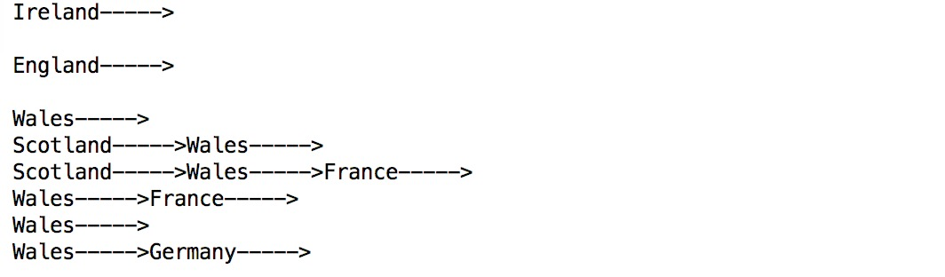

**PCQ4L.java**

**public class** PCQ4L {  
 **public static void** main(String[] args) {  
 LinkedDeque queue = **new** LinkedDeque();  
 System.***out***.println(**"front"** + **"\t"** + **"rear"** + **"\t"**);  
  
 queue.addFirst(**"Ireland"**);  
 System.***out***.println(queue);  
  
 queue.removeLast();  
 System.***out***.println(queue);  
  
 queue.addLast(**"England"**);  
 System.***out***.println(queue);  
  
 queue.removeFirst();  
 System.***out***.println(queue);  
  
 queue.addLast(**"Wales"**);  
 System.***out***.println(queue);  
  
 queue.addFirst(**"Scotland"**);  
 System.***out***.println(queue);  
  
 queue.addLast(**"France"**);  
 System.***out***.println(queue);  
  
 queue.removeFirst();  
 System.***out***.println(queue);  
  
 queue.removeLast();  
 System.***out***.println(queue);  
  
 queue.addLast(**"Germany"**);  
 System.***out***.println(queue);  
 }  
 }